Effect of contact heterogeneity on foot-and-mouth disease spread in random and scale-free farm networks

Abstract
South Africa is experiencing a major outbreak of foot-and-mouth disease (FMD), and many control measures, such as auction closures and movement restrictions, act by altering contact patterns between farms. This study investigated whether the distribution of contacts among farms, rather than their average number alone, influences the epidemic threshold, the timing and magnitude of the epidemic peak, and the final outbreak size of FMD. A discrete-time susceptible–infectious–removed (SIR) model with an assumed farm-level infectious period of 14 days was simulated on Erdős–Rényi random and Barabási–Albert scale-free networks of 300 farms with the same mean degree (⟨k⟩ = 5.96). Transmissibility was varied from 0 to 0.6, with 500 simulations per value and network, and simulated epidemic thresholds were compared with network epidemic theory. The scale-free network had a lower epidemic threshold in both theory (0.090 vs. 0.168) and simulation (0.112 vs. 0.153). At T ≈ 0.25, its major outbreaks peaked about 28 days earlier (95% CI: 25–31 days) and reached a peak prevalence of 27% of farms, compared with 16%. Final outbreak size depended on transmissibility: the scale-free network produced larger outbreaks at low transmissibility, whereas the random network produced slightly larger outbreaks from T ≈ 0.275 to 0.6, possibly because highly connected farms are infected and removed early (a mechanism not tested directly). These results were robust to infectious periods of 9 and 11 days, and theory agreed more closely with simulation for the random network. In these idealized networks, which do not represent measured South African movement networks, contact heterogeneity influenced FMD spread independently of mean degree. This motivates testing control strategies that target highly connected farms, such as auction-associated farms and high-volume dealers, on real movement networks.

1. Introduction

1.1 Background
Foot-and-mouth disease (FMD) is a highly contagious viral disease affecting cloven-hoofed livestock and is one of the most economically damaging animal diseases worldwide, with visible production losses and vaccination in endemic regions alone estimated at US$6.5–21 billion per year (Knight-Jones and Rushton, 2013). South Africa lost its FMD-free status in 2019, and the current epidemic, which began in 2021, has been described as the most severe in the country’s recent history (Burton, 2026). By March 2026, the disease had spread to all nine provinces, with more than 900 outbreaks formally reported to the World Organization for Animal Health (Roos, 2026). Outbreaks involving serotype SAT2 continue to be reported, while a SAT1 strain was identified in Gauteng in late 2025 and new cases have been linked to the movement of infected animals (RMIS, 2025). The Bureau for Food and Agricultural Policy estimate that FMD could cost the livestock sector approximately R13.1 billion in lost production and export revenue over the next five years (BFAP, 2026, cited in Thompson, 2026).
FMD transmission between farms is influenced by the movement and contact patterns of livestock. Potential routes of transmission include animal trading, shared transport, shared equipment, and contact at auctions and dip tanks. These connections can be represented as a contact network, in which each farm is a node and each link represents a potential route through which infection can spread between farms. Several FMD control measures implemented in South Africa, including auction closures, restrictions on animal movement, and the quarantine of affected premises, can alter these contact patterns (DALRRD, 2022). Understanding how the structure of farm networks influences disease transmission is therefore important for identifying farms and connections that may warrant targeted surveillance and control.

1.2 Network epidemiology and FMD
Classical compartmental models, such as the susceptible–infectious–removed (SIR) model, assume homogeneous mixing, in which every individual has a similar chance of contacting every other, and summarize transmission with the basic reproduction number R₀, the expected number of secondary infections caused by one infected individual in a fully susceptible population. Livestock contacts are not homogeneous: some farms trade with many others, while most trade with only a few. Network models represent this structure explicitly. The number of links a farm has is its degree (k), the average over all farms is the mean degree ⟨k⟩, the way links are shared among farms is the degree distribution, and farms with far more links than most are hubs.
A central result of network epidemiology is that spread depends not only on the mean degree but also on how unevenly links are distributed. Newman (2002) defined transmissibility (T) as the probability that infection passes along a single link during the infectious period, and showed that a major epidemic is possible only when T exceeds the epidemic threshold
$$T_{c}=\frac{⟨k⟩}{⟨k^{2}⟩-⟨k⟩}$$

where ⟨k²⟩ is the mean squared degree (Section 2.5). Because hubs increase ⟨k²⟩ even when ⟨k⟩ is unchanged, networks with heterogeneous contacts have lower thresholds. For a random network with approximately Poisson degree distribution, the threshold simplifies to
$$T_{c}≈\frac{1}{⟨k⟩}$$

In finite networks such as those studied here, hub size is limited, so a non-zero threshold remains (Pastor-Satorras and Vespignani, 2001, 2002).
Heterogeneity also affects outbreak dynamics. In heterogeneous networks, infection tends to reach hubs first and then cascades to less connected nodes, producing faster early growth (Barthélemy et al., 2004). Its effect on final outbreak size, the proportion of farms ever infected, is less straightforward: in a study of contact tracing on random and scale-free networks with the same mean degree, Kiss, Green and Kao (2006) found that the scale-free network produced a smaller final epidemic once transmission exceeded a threshold rate.
Network approaches have been applied to FMD through livestock movement networks in Great Britain, where the risk of a large national epidemic depended on the structure and seasonal timing of movements (Kao et al., 2006), and movements alone could generate a large epidemic only under particular conditions, such as heavy cattle involvement (Green, Kiss and Kao, 2006). In cattle, the infectious period of FMD has been estimated at 10.8 days (95% CI 8.2–14.2) and the latent period at 1.5 days (Yadav et al., 2019).

1.3 Research gap
Previous applications of network epidemiology to FMD have used national movement networks containing thousands of holdings (Kao et al., 2006; Green, Kiss and Kao, 2006), and much of the underlying theory was developed for generic epidemics on very large, idealized networks. It is therefore unclear how well these predictions describe FMD in a small, finite farm network. In such a network the maximum degree is limited, the assumption behind the threshold formula that short loops are rare (Newman, 2002) may not hold where hubs share neighbors, and the effect of heterogeneity on final outbreak size may differ between low and high transmissibility.
This scale is relevant to South Africa, where FMD is controlled through disease management areas, protection zones, quarantine and restrictions on auctions and animal movement, and where outbreaks have been linked to illegal movements and livestock auctions (DALRRD, 2022). Network analyses of South African cattle movements remain limited, although highly central dip tanks have been identified locally (Ngoshe et al., 2025). A simulated network of 300 farms does not represent any specific region, but it allows contact heterogeneity to be varied while the mean degree is held constant. The gap addressed by this study is therefore how established network epidemic predictions apply to FMD transmission in a small, finite farm network when contact heterogeneity is varied independently of mean degree.

1.4 Aim, research question, hypotheses and objectives
Aim: The aim of this study is to determine how contact heterogeneity influences the epidemic threshold, the timing and magnitude of the epidemic peak, and the final outbreak size of FMD when the mean degree of the farm network is held constant.
Research question: How does contact heterogeneity influence the epidemic threshold, the timing and magnitude of the epidemic peak, and the final outbreak size of foot-and-mouth disease in farm networks with a fixed mean degree?
Hypothesis: Contact heterogeneity influences FMD spread independently of the mean number of contacts. Comparing a random (Erdős–Rényi) and a scale-free (Barabási–Albert) network of 300 farms with the same mean degree (⟨k⟩ ≈ 6):
- H(a) Epidemic threshold: the scale-free network will have a lower threshold, because the threshold falls as degree variance rises (Newman, 2002).
- H(b) Epidemic peak: at the same transmissibility, scale-free outbreaks will peak earlier and higher, because infection reaches hubs early and each hub then infects many farms at once (Barthélemy et al., 2004).
- H(c) Final outbreak size: the scale-free network will produce larger outbreaks at low transmissibility, but this difference will disappear or reverse at high transmissibility, as previously reported for scale-free networks (Kiss, Green and Kao, 2006). The prediction is evaluated separately from its proposed mechanism, that hubs are infected and removed early, leaving poorly connected farms that are more likely to escape infection, which was not tested directly.
Objectives:
- Generate matched random and scale-free networks of 300 farms (Erdős and Rényi, 1959; Barabási and Albert, 1999) and compare their degree mean, variance and maximum.
- Implement a discrete-time SIR model of FMD with a 14-day infectious period and transmissibility T = 1 − (1 − p) ^D and validate it against theory on the random network (Newman, 2002).
- Compare theoretical and simulated epidemic thresholds (H(a)).
- Compare peak prevalence, peak timing and duration of major outbreaks at T ≈ 0.25 (H(b)).
- Compare final outbreak sizes across T and identify any crossover (H(c)).
- Test robustness by repeating the simulations with infectious periods of 11 and 9 days.

2. Method

2.1 Study design and variables
FMD transmission between farms was simulated with a stochastic, discrete-time SIR model on random and scale-free networks with the same mean degree. The independent variables were transmissibility (T, 0–0.6) and network type. The dependent variables were the major outbreak proportion, peak prevalence, day of peak, outbreak duration and final outbreak size. Network size, mean degree and infectious period were held constant within each experiment.

2.2 Network construction
Each network had N = 300 farms. A link represents any contact that could transmit FMD (trade, shared transport or equipment); links were undirected and static.
Scale-free network. Networks were generated by Barabási–Albert preferential attachment (Barabási and Albert, 1999): from a fully connected core of 4 farms, each new farm formed m = 3 links to existing farms with probability proportional to their degree, giving ⟨k⟩ ≈ 6 and a minimum degree of 3.
Random network. Each scale-free network was paired with a fixed-link Erdős–Rényi network (Erdős and Rényi, 1959) with the same number of links placed at random, so each pair had the same size and number of links, and therefore the same mean degree. The networks differed mainly in their degree distribution, although other properties, such as clustering, also differed (Section 4.2).
A new network pair was generated for each of the 500 runs, and the same 500 pairs were reused at every value of T, so differences between T values reflect T rather than the networks.

2.3 Transmission model
Each farm was susceptible (S), infectious (I) or removed (R, by recovery or culling). Time advanced in daily steps, with all farms updated simultaneously.
Infection. Each infectious farm infects each susceptible neighbour with daily probability p, so a susceptible farm i with mᵢ(t) infectious neighbours is infected with probability
$$P_{i}\left(t\right)=1-{\left(1-p\right)}^{m_{i}\left(t\right)}$$
Removal and timing. A farm infected on day t is counted as infectious from day t, transmitted on days t + 1 to t + D, and is removed at the end of day t + D. The day of peak is the day with the most infectious farms, counted from the first infection on day 0. Each run began with one randomly chosen infected farm and ended when no infectious farms remained.
Transmissibility. T is the probability that infection crosses a link during the infectious period (Newman, 2002). With D daily attempts, each succeeding with probability p,
$$T=1-{\left(1-p\right)}^{D}$$
This is the discrete-time form of Newman's T = 1 − e^(−rτ). T was chosen first and the daily probability was obtained by inverting Equation 2, so that a given T meant the same on both networks and for every D:
$$p=1-{\left(1-T\right)}^{1/D}$$
Assumptions. Farms were identical; transmission occurred only along links, at the same rate on every link; networks were static; there was no latent period; and no control was applied. The FMD latent period in cattle (about 1.5 days; Yadav et al., 2019) is short relative to the infectious period, so omitting it should mainly affect timing. These assumptions are discussed in Section 4.4.

2.4 Parameters
Parameters are listed in Table 1.
Table 1. Model parameters. Time step (1 day), initial infection (one random farm), reference T (0.254) and random seed (2026) are given in the text.
Parameter | Value | Source or justification
Number of farms, N | 300 | Modelling choice (small region)
Links per new farm, m | 3 | Barabási and Albert (1999); gives ⟨k⟩ ≈ 6
Mean degree, ⟨k⟩ | 5.96 links | Equal on both networks (matched link counts)
Infectious period, D | 14 days (main); 11 and 9 days (sensitivity) | 14: assumption based on 10.8 days (95% CI 8.2–14.2) in cattle; 11: ≈ same estimate (Yadav et al., 2019); 9: infection-to-cull interval (Chis Ster and Ferguson, 2007)
Transmissibility, T | 0–0.6 (60 values) | Covers both thresholds
Daily transmission probability, p | 0–0.063 per day | p = 1 − (1 − T)^(1/D)
Runs per T and network | 500 | Standard error of any proportion ≤ 0.022
Major outbreak | > 10% of farms | Modelling choice
Threshold detection level | 5% of runs (2%, 10% as checks) | Modelling choice

2.5 Theoretical predictions
R₀ and the epidemic threshold were calculated from the degree moments of each network type, averaged over the 500 networks (Newman, 2002):
$$R_{0}=T \frac{⟨k^{2}⟩-⟨k⟩}{⟨k⟩}=T\left(⟨k⟩-1+\frac{Var\left(k\right)}{⟨k⟩}\right)$$
$$T_{c}=\frac{⟨k⟩}{⟨k^{2}⟩-⟨k⟩}$$
Here ⟨k⟩ and ⟨k²⟩ are the mean and mean squared degree, and the fraction in the first form of Equation 4 is the mean excess degree, the average number of further farms a newly infected farm can reach. The second form of Equation 4, obtained using ⟨k²⟩ = ⟨k⟩² + Var(k), shows that at fixed mean degree any difference in R₀ comes from the degree variance. A major outbreak is possible only when R₀ > 1, that is, when T > T_c (Equation 5).
For the approximately Poisson random network, the expected final size S of a major outbreak solves
$$S=1-e^{-T⟨k⟩S}$$
for S > 0 when T⟨k⟩ > 1. The theory assumes large networks without short loops, so it was expected to be accurate for the random network and approximate for the scale-free network at N = 300; for the scale-free network it was used only for the threshold.

2.6 Simulation experiments and analysis
Main experiment. T took 60 equally spaced values from 0 to 0.6 (step ≈ 0.010), with 500 runs per value and network (60,000 runs).
Outcomes. Each run recorded the final size (proportion of farms ever infected), peak prevalence (largest proportion infectious on one day), day of peak and duration. A run infecting more than 10% of farms (> 30) was a major outbreak. The major-outbreak proportion was calculated over all runs; the other outcomes were averaged over major outbreaks only, so early die-outs did not distort them.
Threshold (H(a)). The simulated threshold was the first T at which the major-outbreak proportion exceeded 5% (standard error ≈ 0.01 at 500 runs); 2% and 10% levels were used as checks.
Peak (H(b)) and final size (H(c)). Peak outcomes were compared at every T where both networks had at least 5% major outbreaks, and in detail at T = 0.254 (p ≈ 0.021 per day), which lies above both thresholds and gives similar final sizes, so differences reflect speed rather than extent. Final sizes were compared at every T to find where the difference changed sign.
Statistics. Differences in mean peak day and final size were given 95% confidence intervals, difference ± 1.96√(s₁²/n₁ + s₂²/n₂); an interval excluding zero was taken as support. These intervals are pointwise. Because final size was compared at 45 values of T, each difference was also tested with a two-sided z-test at a Bonferroni-corrected level of α = 0.05/45 ≈ 0.0011. Outbreaks were treated as independent samples: although run r used network pair r on both networks, the starting farms and network types differed and the sets of runs producing major outbreaks did not coincide, so there was no meaningful pairing.
Validation and sensitivity. Farm numbers were checked to be conserved, and random-network results were compared with theory (Section 2.5). To assess short loops, the number of triangles and the clustering coefficient (NetworkX transitivity) were calculated for 200 additional network pairs. The experiment was repeated with D = 11 and 9 days (p recalculated so T was unchanged) and with a 25-value T grid.

2.7 Implementation and code availability
The model was written in Python 3 (NumPy, SciPy, NetworkX, pandas, Matplotlib), using sparse adjacency matrices. All settings are in config.py, run_all.py reproduces every table and figure, extra_checks.py reproduces the Bonferroni and short-loop checks, and a fixed seed (2026) makes results reproducible. Code: https://github.com/IkramDanger/Bio_Math_FMD.

3. Results

3.1 Network properties
Both networks had the same mean degree (k⟩ = 5.96) but very different link distributions (Table 2). Degree variance was over six times higher in the scale-free network (36.6 vs 5.8) and its largest hub had 84 links, compared with 20 in the random network, where a few farms had no links. This raised the mean excess degree from 5.94 to 11.09 and lowered the theoretical threshold from 0.168 to 0.090.
Table 2. Degree statistics of the two networks, averaged over all 500 network pairs generated.
Network | ⟨k⟩ | ⟨k²⟩ | Variance | Minimum degree | Maximum degree | (⟨k²⟩ − ⟨k⟩)/⟨k⟩ | Theoretical threshold, T_c
Random | 5.96 | 41.3 | 5.8 | 0 | 20 | 5.94 | 0.168
Scale-free | 5.96 | 72.1 | 36.6 | 3 | 84 | 11.09 | 0.090

3.2 Epidemic thresholds (H(a))
On both networks the major-outbreak proportion stayed near zero at low T and then rose, but the rise began earlier on the scale-free network (Figure 1). The simulated threshold was 0.112 for the scale-free network and 0.153 for the random network (theory: 0.090 and 0.168), about 27% lower, supporting H(a). Simulation fell slightly below theory for the random network and above it for the scale-free network, and the scale-free network had the lower threshold at all three detection levels (Table 3).
Table 3. Theoretical and simulated epidemic thresholds. Simulated thresholds are the first tested transmissibility at which the major-outbreak proportion exceeded the stated detection level.
Network | Theoretical T_c | Simulated (2% level) | Simulated (5% level, main) | Simulated (10% level)
Random | 0.168 | 0.142 | 0.153 | 0.173
Scale-free | 0.090 | 0.102 | 0.112 | 0.122
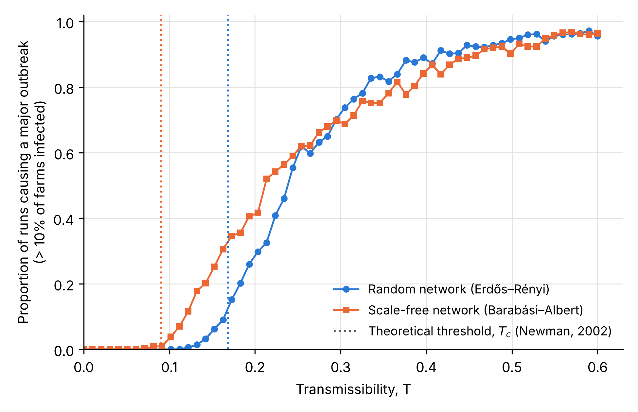
Figure 1. Proportion of 500 simulations in which a single infected farm caused a major outbreak (more than 10% of farms infected), across 60 values of transmissibility T from 0 to 0.6 (D = 14 days). Dotted vertical lines show the theoretical epidemic thresholds (Newman, 2002): blue, T_c = 0.168 for the random network; orange, T_c = 0.090 for the scale-free network.

3.3 Peak prevalence and timing (H(b))
At all 45 values of T at which both networks had at least 5% major outbreaks (T = 0.153–0.600), scale-free outbreaks peaked earlier and higher (Figure 2). At T = 0.254 (Table 4), both networks produced major outbreaks in 62% of runs with almost identical final sizes (59.0% vs 59.4%; difference 0.5 percentage points, 95% CI −0.6 to 1.5), yet scale-free outbreaks peaked with 27.1% of farms infected at once versus 16.4% (about 65% higher; difference 10.7 percentage points, 95% CI 10.1–11.4), on day 44.1 versus 72.3 (difference 28.1 days, 95% CI 25.1–31.1), and ended after 96 rather than 146 days (difference 51 days, 95% CI 47–55). This supports H(b). On the random network, peaks were latest at intermediate T (about 0.21–0.25), because growth is slow near the threshold.
Table 4. Peak prevalence and duration of major outbreaks at T = 0.254 (D = 14 days; 310 major outbreaks on each network).
Network | Major outbreaks (%) | Final size (% of farms) | Peak prevalence (% of farms) | Peak prevalence (farms) | Day of peak | Duration (days)
Random | 62 | 59.0 | 16.4 | 49 | 72.3 | 146
Scale-free | 62 | 59.4 | 27.1 | 81 | 44.1 | 96
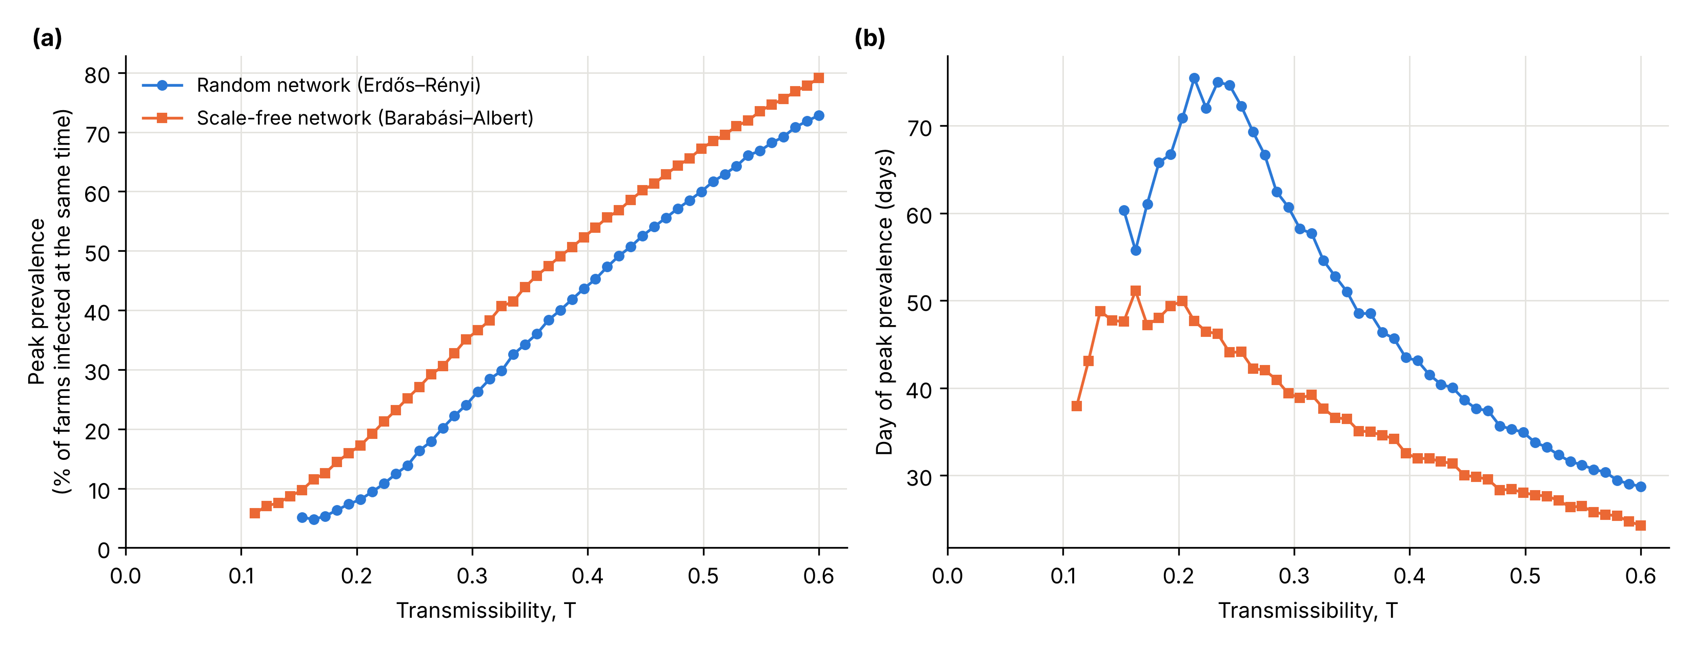
Figure 2. Speed of major outbreaks on each network. (a) Peak prevalence, the largest percentage of farms infected at the same time. (b) Day on which the peak occurred; lower values mean an earlier peak. Values are averages over major outbreaks (more than 10% of farms infected) and are shown only where at least 5% of simulations produced a major outbreak, as averages based on fewer outbreaks are unreliable.

3.4 Final outbreak size (H(c))
The effect of heterogeneity on final size depended on T (Figure 3). At low T, scale-free major outbreaks were larger, by up to 43 farms (14% of farms) at T ≈ 0.17, and the 95% CI for the difference excluded zero from T = 0.153 to 0.244. The difference was not significant at T = 0.254 or 0.264. From T = 0.275 upwards the relationship reversed: random-network outbreaks were larger at all 33 values up to 0.6, with every CI excluding zero, although the difference was small (at most 13 farms, 4.5%, at T ≈ 0.37) and shrank as both networks approached complete infection (97.0% vs 96.6% at T = 0.6). All of these differences, on both sides of the crossover, remained significant after Bonferroni correction for the 45 comparisons. The major-outbreak proportion crossed at a similar point (T ≈ 0.25–0.26; Figure 1). These results support H(c).
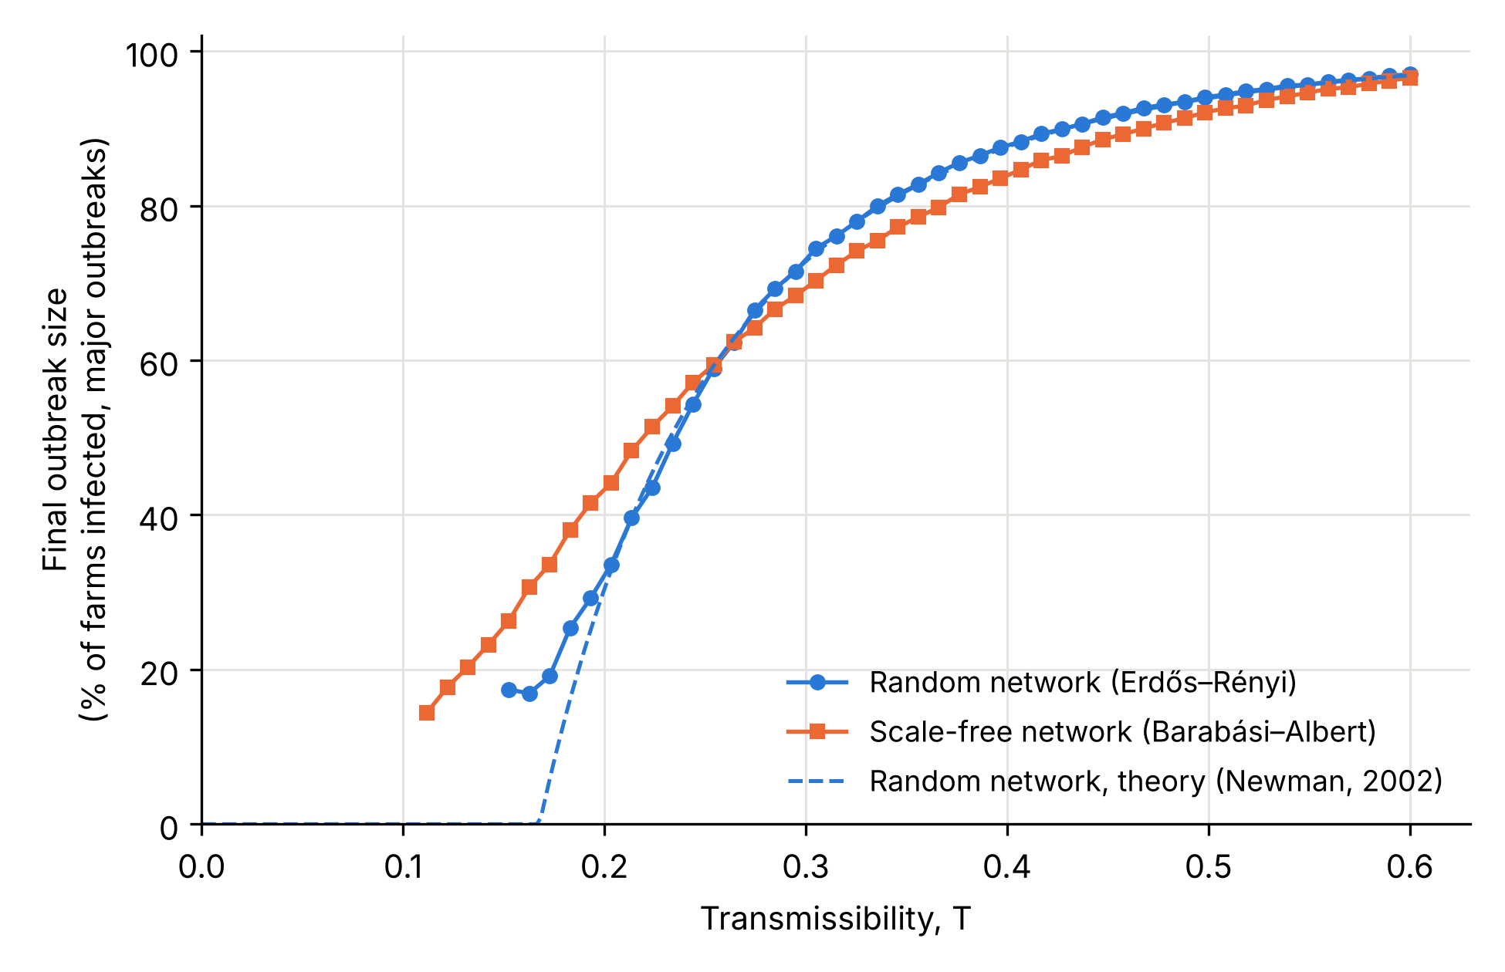
Figure 3. Final size of major outbreaks (percentage of farms ever infected) on each network across transmissibility T. The dashed line is the theoretical final size for the random network (Newman, 2002). Points are shown only where at least 5% of simulations produced a major outbreak. The two networks cross at T ≈ 0.26–0.275, above which the random network has slightly but consistently larger outbreaks.

3.5 Model validation and robustness
The number of farms stayed at 300 in every run. For the random network, simulated and theoretical final sizes differed by 0.3 percentage points on average for T ≥ 0.2 (maximum 1.9), and the major-outbreak proportion matched the theoretical final size to within 1.5 percentage points on average, as Newman (2002) predicts when transmissibility is the same on every link. Agreement was weaker for the scale-free network (threshold 0.022 above theory).
With infectious periods of 11 and 9 days (T held fixed by recalculating p), thresholds were unchanged, final sizes were similar, and the crossover stayed at T ≈ 0.26–0.275 (Table 5). Shorter periods made peaks slightly earlier and lower on both networks, but the scale-free network still peaked earlier and higher at every T. Repeating the main experiment with 25 values of T gave the same thresholds and qualitative results.
Table 5. Sensitivity of the main results to the infectious period D. Peak and final-size values are for major outbreaks at T = 0.254.
D (days) | Threshold, random / scale-free | Peak prevalence (%), random / scale-free | Day of peak, random / scale-free | Final size (%), random / scale-free | Crossover T
14 (main) | 0.153 / 0.112 | 16.4 / 27.1 | 72.3 / 44.1 | 59.0 / 59.4 | 0.275
11 | 0.153 / 0.112 | 15.7 / 26.6 | 57.1 / 34.5 | 58.9 / 59.5 | 0.264
9 | 0.153 / 0.112 | 15.7 / 26.2 | 48.2 / 28.8 | 59.2 / 59.6 | 0.264

4. Discussion

4.1 Summary of findings
All three parts of the hypothesis were supported. With the mean degree held equal, the scale-free network had a lower epidemic threshold in theory (0.090 vs 0.168) and simulation (0.112 vs 0.153) (H(a)); its outbreaks peaked earlier and higher at every T, by about 28 days and 65% at T = 0.254, where final sizes were nearly identical (H(b)); and it produced larger outbreaks at low T, but slightly smaller ones above T ≈ 0.275 (H(c)). These conclusions are held for infectious periods of 11 and 9 days.

4.2 Comparison with theory and previous studies
The lower scale-free threshold matches network epidemic theory: at fixed mean degree, the threshold falls as degree variance rises (Newman, 2002), so the difference here is attributable to variance (36.6 vs 5.8). The threshold did not vanish, as it would in an infinite scale-free network (Pastor-Satorras and Vespignani, 2001), because hub size is limited in a network of 300 farms (Pastor-Satorras and Vespignani, 2002).
Theory and simulation agreed closely for the random network, which supports the correctness of the code, but less well for the scale-free network, whose simulated threshold was 24% above theory (0.112 vs 0.090), compared with 9% below theory for the random network (0.153 vs 0.168). Two explanations are consistent with these results, although neither was tested directly. First, Newman's theory assumes networks with few short loops, but the scale-free networks contained about four times as many triangles as the random networks (mean 155 vs 35; clustering coefficient 0.047 vs 0.020), and the two largest hubs shared about 10 neighbors on average. When infection reaches a farm that is already infected or removed through a second route, that link adds nothing to spread, so the theory overestimates the number of new farms each hub can reach and places the threshold too low. In addition, near the threshold a scale-free outbreak becomes major only if it reaches a hub, so the major-outbreak proportion crosses the 5% detection level late. Because the detection rule placed the random-network threshold slightly below theory, it probably narrows rather than exaggerates the difference between networks.
The earlier, higher scale-free peak agrees with Barthélemy et al. (2004), who showed that outbreaks on heterogeneous networks reach hubs first and grow faster. The final-size reversal agrees with Kiss, Green and Kao (2006), who found smaller final epidemics on scale-free than random networks above a threshold transmission rate, although in a model that also included contact tracing. A possible mechanism is that hubs are infected and removed early, leaving many farms with only three links and few routes for infection, whereas most random-network farms have about six; this was not tested directly. The few unconnected farms in the random network reduced their final size, so the reversal occurred despite them, not because of them.

4.3 Implications for FMD control in South Africa
The mean number of contacts alone is not enough to judge a region's vulnerability to FMD. A region whose trade runs through a few highly connected farms, such as auction-linked farms or high-volume dealers, may allow a weakly transmissible strain to cause a major outbreak, and its outbreaks are likely to peak sooner, leaving less time to respond. This fits South African experience, where outbreaks have been linked to auctions and illegal movements (DALRRD, 2022) and a few dip tanks are highly central in local movement networks (Ngoshe et al., 2025).
These findings suggest that highly connected farms and trading points may be useful priorities for surveillance and targeted control, such as closing auctions or restricting high-volume traders. In network terms, such measures would reduce degree variance and could raise the threshold while disrupting fewer farms than uniform restrictions. However, the effectiveness of such interventions was not evaluated in this model and should be tested using realistic movement networks and explicit intervention scenarios. The crossover also suggests that such targeting is most valuable early in an outbreak and for less transmissible strains; at high transmissibility, broad movement restrictions and vaccination remain necessary.

4.4 Limitations
Simulated networks. The networks were idealized rather than built from movement data. The mean degree of six was a modelling choice; the only South African estimate found (about 4.3 links per node) is from a single, non-peer-reviewed protection-zone study (Lazarus et al., 2020). This affects absolute thresholds but not the comparison, because the mean degree was equal on both networks.
Static, undirected, identical. Real movements are directed and vary with auction days and seasons (Kao et al., 2006). Farms were treated as identical, although cattle farms are more infectious and susceptible than sheep farms (Chis Ster and Ferguson, 2007). Local spread (Green, Kiss and Kao, 2006) and transmission from African buffalo, the main reservoir of SAT serotypes (Brito et al., 2016), were excluded.
Disease timing and control. The 14-day infectious period is extrapolated from cattle estimates for serotypes O, A and Asia1 rather than SAT types (Yadav et al., 2019). The 11- and 9-day analyses showed the conclusions do not depend on it, but no latent period was included, which probably makes peaks too early. No control was modelled, so the results describe potential rather than managed spread.
Analysis. The threshold depends on an operational detection rule, and the crossover mechanism was not tested directly.

4.5 Future directions
- Real movement data: build networks from South African movement permits (Ngoshe et al., 2025), with direction and seasonal timing (Kao et al., 2006), to see whether real networks resemble the scale-free or random case.
- More realistic disease: add a latent period (SEIR), differences in herd size and species, local spread and buffalo contact.
- Control strategies: compare removing or vaccinating the most connected farms with random removal of the same number, across T.
- Mechanism and estimation: record the degree of farms when infected to test the crossover mechanism, and compare alternative threshold estimators (Crépey, Alvarez and Barthélemy, 2006) across network sizes.

5. Conclusion
In a network SIR model of FMD among 300 farms with the same mean degree, concentrating contacts in a few hubs lowered the epidemic threshold and made outbreaks peak about four weeks earlier and higher. Hubs increased final outbreak size when transmission was weak, but at high transmissibility the evenly connected network produced slightly larger outbreaks. These findings were robust to the infectious period and matched network theory, closely for the random network and approximately for the scale-free network.
The average number of farm contacts is therefore not sufficient to predict FMD risk; how those contacts are distributed also matters. For South Africa, this suggests that highly connected farms and trading points may be useful priorities for surveillance and control, especially early in an outbreak, alongside broader measures for highly transmissible strains, although such interventions were not tested here. Testing these conclusions on real South African movement networks is the most important next step.

References
- Barabási, A.-L. and Albert, R. (1999) 'Emergence of scaling in random networks', Science, 286(5439), pp. 509–512. doi:10.1126/science.286.5439.509.
- Barthélemy, M., Barrat, A., Pastor-Satorras, R. and Vespignani, A. (2004) 'Velocity and hierarchical spread of epidemic outbreaks in scale-free networks', Physical Review Letters, 92, 178701.
- Brito, B.P., Jori, F., Dwarka, R., Maree, F.F., Heath, L. and Perez, A.M. (2016) 'Transmission of foot-and-mouth disease SAT2 viruses at the wildlife–livestock interface of two major transfrontier conservation areas in Southern Africa', Frontiers in Microbiology, 7, 528. doi:10.3389/fmicb.2016.00528.
- Burton, L. (2026) 'South Africa's foot and mouth disease crisis will take ten years to combat', Beef Central, 21 January.
- Chis Ster, I. and Ferguson, N.M. (2007) 'Transmission parameters of the 2001 foot and mouth epidemic in Great Britain', PLoS ONE, 2(6), e502.
- Crépey, P., Alvarez, F.P. and Barthélemy, M. (2006) 'Epidemic variability in complex networks', Physical Review E, 73(4), 046131. doi:10.1103/PhysRevE.73.046131.
- DALRRD (2022) Minister Thoko Didiza provides update on the foot-and-mouth disease outbreak in South Africa, 11 April. Pretoria: Department of Agriculture, Land Reform and Rural Development.
- Erdős, P. and Rényi, A. (1959) 'On random graphs I', Publicationes Mathematicae Debrecen, 6(3–4), pp. 290–297. doi:10.5486/pmd.1959.6.3-4.12.
- Green, D.M., Kiss, I.Z. and Kao, R.R. (2006) 'Modelling the initial spread of foot-and-mouth disease through animal movements', Proceedings of the Royal Society B, 273(1602), pp. 2729–2735.
- Kao, R.R., Danon, L., Green, D.M. and Kiss, I.Z. (2006) 'Demographic structure and pathogen dynamics on the network of livestock movements in Great Britain', Proceedings of the Royal Society B, 273(1597), pp. 1999–2007. doi:10.1098/rspb.2006.3505.
- Kiss, I.Z., Green, D.M. and Kao, R.R. (2006) 'Infectious disease control using contact tracing in random and scale-free networks', Journal of the Royal Society Interface, 3(6), pp. 55–62. doi:10.1098/rsif.2005.0079.
- Knight-Jones, T.J.D. and Rushton, J. (2013) 'The economic impacts of foot and mouth disease – What are they, how big are they and where do they occur?', Preventive Veterinary Medicine, 112(3–4), pp. 161–173.
- Lazarus, D., Opperman, P., Sirdar, M., Wolf, T., van Wyk, I. and Rikhotso, O. (2020) 'Improving foot-and-mouth disease control using livestock movement patterns within the FMD protection zone of South Africa', Authorea (preprint). doi:10.22541/au.159769321.18144426.
- Newman, M.E.J. (2002) 'Spread of epidemic disease on networks', Physical Review E, 66(1), 016128.
- Ngoshe, Y.B., Gomez-Vazquez, J.P., Etter, E.M.C. and Thompson, P.N. (2025) 'Characterization of domestic ruminant movement patterns in a transfrontier region of north-eastern KwaZulu-Natal, South Africa', Transboundary and Emerging Diseases, 2025, 4507408.
- Pastor-Satorras, R. and Vespignani, A. (2001) 'Epidemic spreading in scale-free networks', Physical Review Letters, 86(14), pp. 3200–3203.
- Pastor-Satorras, R. and Vespignani, A. (2002) 'Epidemic dynamics in finite size scale-free networks', Physical Review E, 65(3), 035108.
- RMIS (2025) Foot & mouth disease update, 7 November. Red Meat Industry Services.
- Roos, T. (2026) 'FMD outbreak reaches all provinces, with almost 1,000 cases reported', Business Day, 3 March.
- Thompson, D. (2026) 'John Steenhuisen's national disaster could cost South Africa R13 billion', Daily Investor, 10 June.
- Yadav, S., Stenfeldt, C., Branan, M.A., Moreno-Torres, K.I., Holmstrom, L.K., Delgado, A.H. and Arzt, J. (2019) 'Parameterization of the durations of phases of foot-and-mouth disease in cattle', Frontiers in Veterinary Science, 6, 263. doi:10.3389/fvets.2019.00263.

